CSA0734-COMPUTER NETWORKS FOR SERVER MANAGEMENT

NAME: SAKTHIVEL V

REG. NO.: 192211689

EXPERIMENT 26

Network Layer Protocol Header analysis-UDP

Aim:

  To perform network layer protocol header analysis using Wireshark-UDP.

Tools Required:

   1.Wireshark software.

  2.Protocols.

  3.Network system.

Procedure:

   STEP 1: Firstly, open the Wireshark software and click on the

 wi-fi option.

**STEP** 2: Open the system which will be either connected to the UDP protocol systems.

**STEP** 3: We can identify the running process by calculating the function.

**STEP** 4: Capture the packets and select any IP address from the source.

**STEP** 5: All the packets will be filtered using filter option and source address.

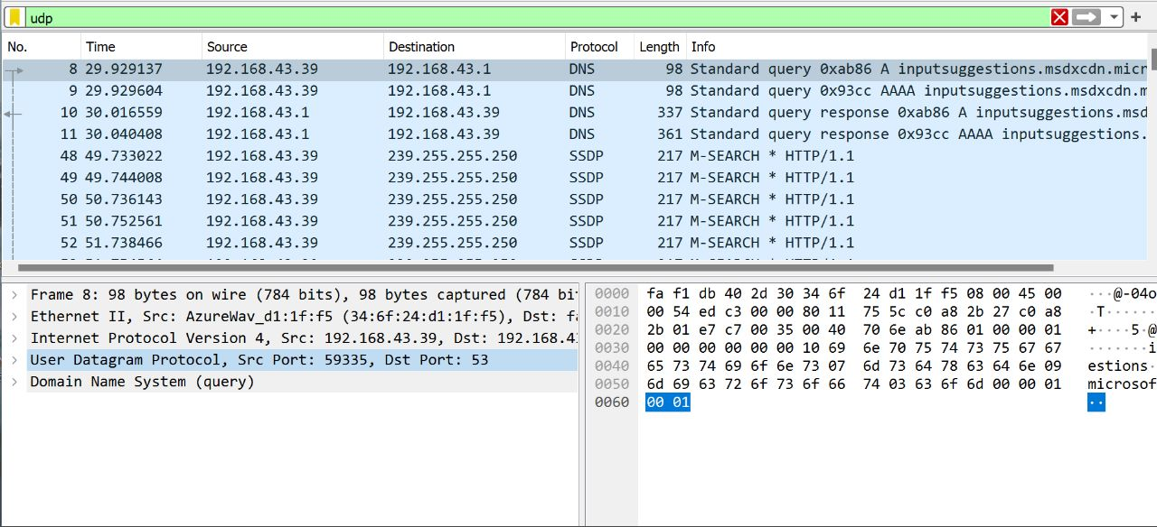

Result:

 The header analysis of UDP has been executed Successfully.